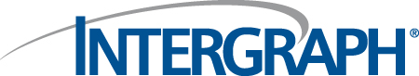
PinJig Accuracy Check Rules –
Structural Manufacturing

PinJig Accuracy Check Rules.doc
Status: Draft
Author: StructMfg-Team

SM3D Concept Design Document.
December 8 , 2011
© 2011 Intergraph Corporation. All rights reserved.
The content of this document is proprietary work of Intergraph Corporation, or relevant third parties, and is protected by copyright law and international treaty. Any use, duplication, distribution or disclosure of such, other than as specified herein, is unauthorized and in violation of applicable copyright law and international treaty. All rights in content or materials bearing copyright notice or other attribution of third party rights are reserved to the relevant third party. United States Government license rights are limited to those mandatory rights identified in DFARS 252.227-7015(b).
Intergraph may make improvements and/or changes in the products and/or the programs described in this publication at any time without notice.
Any content or materials supplied hereunder are provided "as is," without warranty of any kind, either expressed or implied, including, but not limited to, any implied warranties of merchantability, fitness for a particular purpose, or against infringement. In no event shall Intergraph be liable for any damages arising out of, or in connection with the downloading, viewing, use, duplication, distribution or disclosure of any content or material published by Intergraph, including but not limited to any direct, indirect, incidental, special, punitive or consequential damages, or loss or corruption of data.
Some jurisdictions do not allow the exclusions or limitations set forth above, so the above may not apply to you. The exclusions or limitations shall apply in all jurisdictions to the maximum extent allowed by law.

Intergraph Corporation
170 Graphics Drive
Madison, AL 35758
Phone: +1.256.730.2000
Toll Free USA: +1.800.345.4856
Fax: +256.730.2048

Contents
Introduction 2
References 2
Definitions 2
Requirements 3
Bulkload 4
Rule Framework and Implementation 6

Revision # | Date Revised | Revised By | Description
0.1 | 12- Dec- 2011 | Suma Mallena | Initial Version.

Introduction
The purpose of this document is to describe the framework of PinJig Accuracy Check rule. This rule supports the following:
- Customization of remarking bend (cusp) points
- Customization of accuracy check points

References

DI-CP-200008 | Additional accuracy check points for pinjig

Definitions

Requirements
The reqirement is to allow users to create additional accuracy check points on pin jig when necessary through GUI and provide rule framework to customize the behavior.
User can pick the required ‘Accuracy Check Rule Set’ from the ‘Accuracy Check Points’ category from the pin jig property page.
The rule can be switched On/Off from the “Apply Rule” check box. The rule can be customized as described below.
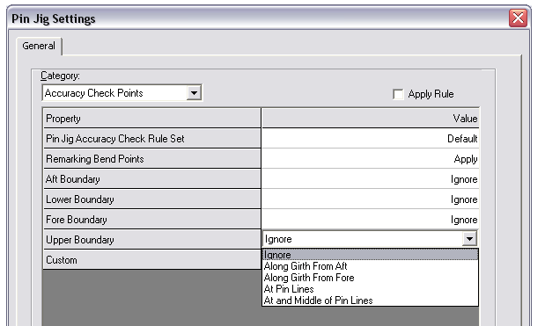

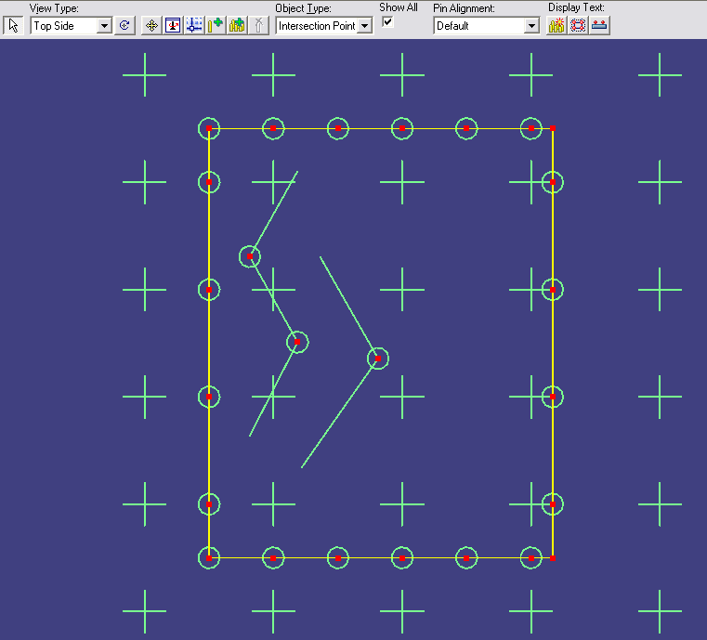

Below are the various properties to define the accuracy points:
- Pin Jig Accuracy Check Rule Set: Specifies the rule set that the software uses to get the accuracy points. User can modify/add the rule sets.
- Remarking Bend Points ( cusps): Specifies whether cusp points are applied or ignored. If applied, the default rule proposes to create the cusp point on a remarking line where the cusp angle is greater than 5 degrees.
- Aft Boundary: Specifies the accuracy points on the Aft Boundary.
- Lower Boundary: Specifies the accuracy points on the Lower Boundary.
- Fore Boundary: Specifies the accuracy points on the Fore Boundary.
- Upper Boundary: Specifies the accuracy points on the Upper Boundary.
- Custom: Specifies the custom accuracy points.

Below are the various values to define the accuracy points:
- Along Girth From Lower: Points are created starting from the Lower boundary at a specified distance along the girth.
- Along Girth From Upper: Points are created starting from the Upper boundary at a specified distance along the girth.
- Along Girth From Aft: Points are created starting from the Aft boundary at a specified distance along the girth.
- Along Girth From Fore: Points are created starting from the Fore boundary at a specified distance along the girth.
- At Pin Lines: Points are created at the intersection of pin rows and columns with the boundary.
- At and Middle of Pin Lines: Points are created at the intersection of pin rows and columns with the boundary. Additional points are created at the middle of these points

Bulkload
Rule is available as a SRD rule in “MfgPinJigRules” which has RuleType = 413 in “StructMfgSettings.xls”. User can modify the ProgID of the existing rule or add new rule by bulkloading in AMD mode..

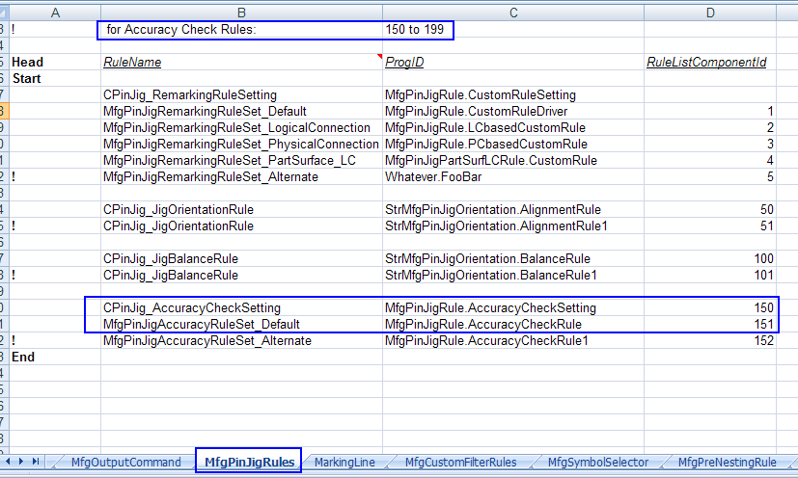

If a new rule is added, the RuleName should have corresponding CodeList Number ( same as RuleListComponntId) in sheet MfgPinJigAccuracyRuleSet of AllStructMfgCodeLists.xls.

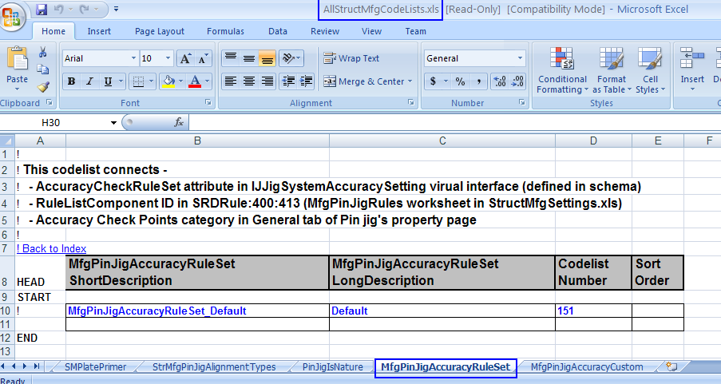

The default rule is implemented in \\SharedContent\Src\StructManufacturing\Rules\PinJig\Remarking.
Below two new class files have been added to “Remarking” project to support the requirement.
- AccuracyCheckSetting.cls
- AccuracyCheckRule.cls

Rule Framework and Implementation
The rule is delivered at “\SharedContent\Src\StructManufacturing\Rules\PinJig\ Remarking”.
- “AccuracyCheckSetting.cls” is the class file which has the default settings for various accuracy check points.
- “AccuracyCheckRule.cls” is the class file which has the default rule implementation for various accuracy check points.
The following method has been exposed on IJDPinJigAccuracyRuleSetting interface:
1. InitialAccuracyRuleSetting
Signature: Private Sub IJDPinJigAccuracyRuleSetting_InitialAccuracyRuleSetting(ByVal PartialPinJig As Object, ByVal AttributeColl As Object)
Inputs:
- Pinjig
- Collection of Attributes representing various Accuracy Check Points

Output: Collection of Attribute Values representing various Accuracy Check Points.
Description: This method specifies the default setting for various attributes that are exposed in pinjig settings page. User can change the attribute value if required.

Select Case oAttrInfo.Name
Case "AccuracyCheckRuleSet"
oAttribute.Value = 151 'MfgPinJigAccuracyRuleSet_Default
Case "BendPoints"
oAttribute.Value = 1 'Apply
Case "AftBoundary"
oAttribute.Value = 0 ‘Ignore

The following method has been exposed on IJDPinJigAccuracyRule interface:
1. GetAccuracyObjectsForPurpose
Signature: Private Function IJDPinJigAccuracyRule_GetAccuracyObjectsForPurpose(ByVal PartialPinJig As Object, ByVal AttributeName As String, ByVal AttributeValue As Variant) As IJMfgGeomCol3d
Inputs:
- Pinjig
- Attribute Name
- Attribute Value
Output: Collection of 2D Accuracy Points/ Bend (cusp) points as IJMfgGeomCol3d
Description: This method creates the Cusp points ( remarking bend points) /Accuracy Points and returns the collection. User can customize the cusp angle for bend (cusp) point creation, the names, girth distance from the reference remarking line for the accuracy points.
Sample Usage for Bend Points creation:
If user desires to create bend points on a remarking line with a different bend angle, it can be changed. The name of the point can also be changed.
Select Case AttributeName
Case "BendPoints"

' Get tha cusp points with cusp angle = 5 degrees
oPinJigReport.GetCuspPointsCollection oRemarkingLineColl, 0.09, oCuspPointColl, oParentRemarkColl

strAccuracyPointName = "Cusp Point on " & oNamedItem.Name

Sample Usage for Accuracy Points creation:
If user desires to create accuracy points on a remarking line with a different girth distance, it can be changed. The name of the point can also be changed.

Case "AftBoundary"

Select Case AttributeValue
Case 1 'Along Girth From Lower
Set oAccuracyPointColl = oPinJigReport.GetAccuracyCheckPtsAlongGirth(o3DCountourLine, 0.5, oReferenceCountourLine)

' Set the Name
Set oNamedItem = o3DCountourLine
strAccuracyPointName = "AP_" & iCounter & "_" & oNamedItem.Name

Note:
Below are the routines exposed on IJDPinjigReport by which user can get various positions on pinjig
- GetCuspPointsCollection
- GetAccuracyCheckPtsAlongGirth
- GetAccuracyCheckPtsAtPinGridLines

‘AddGeom3dAndSetParentRML’ does create Geom3D for the positions and relate them to the parent remarking line.

Future Considerations

